**How to use streamlit apps**

1. **Installation**

Step1: open computer terminal, input pip install streamlit, press enter

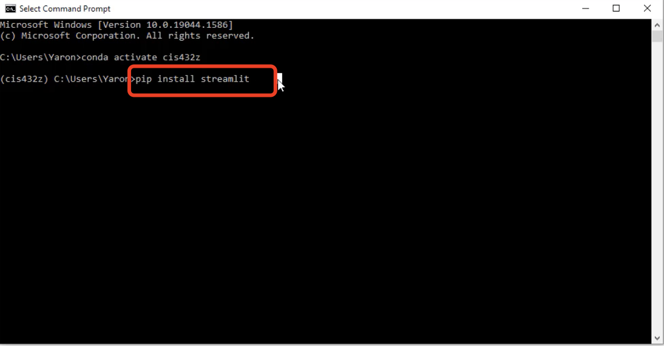

1. **launch**

Step1: open computer terminal, change working directory to the streamlit:

input cd directory*, press enter

* cd must have a space after it.

* Directory is where your streamlit file saved, you can directly drag the file into the command prompt of the terminal, the working directory of the file will automatically appear. Then you need to delete a slash and the file name(/interface_code.py), remain the rest directory, this is the right working directory.

Directory after drag the file into the command prompt of the terminal:

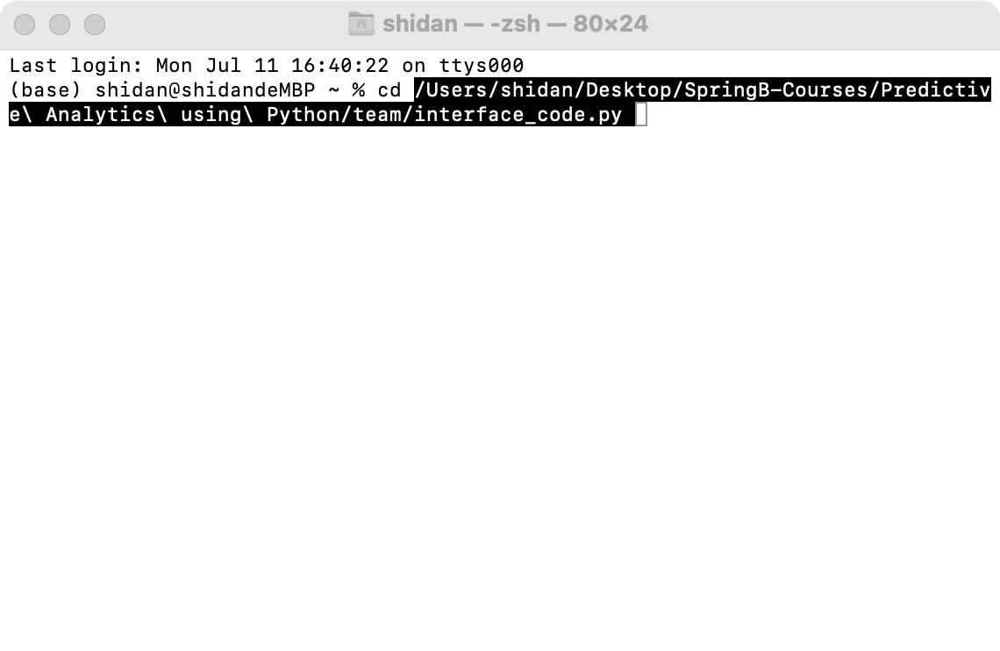

Directory after delete a slash and the file name (/interface_code.py), press enter:

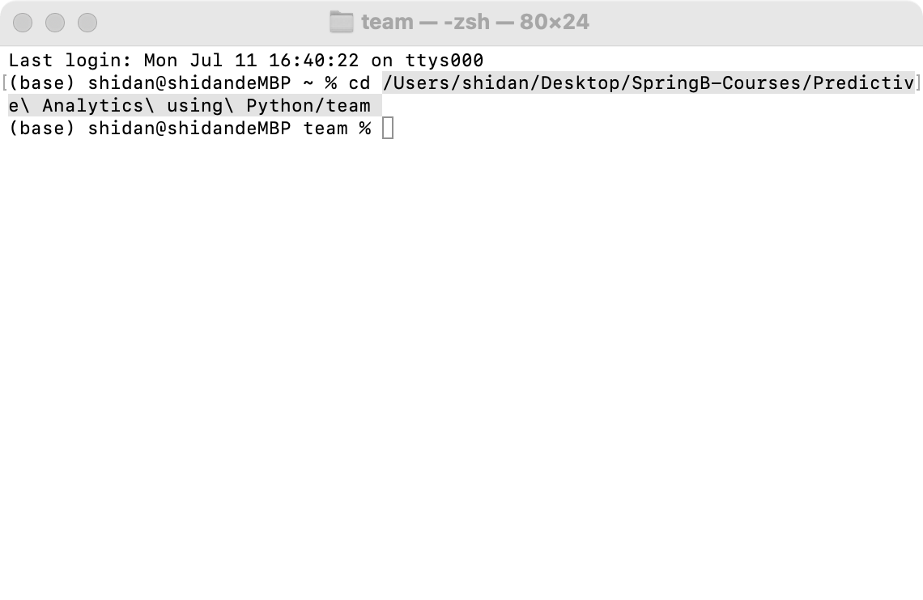

Step2: input streamlit run "interface_code.py", press enter. The interface app will show automatically.

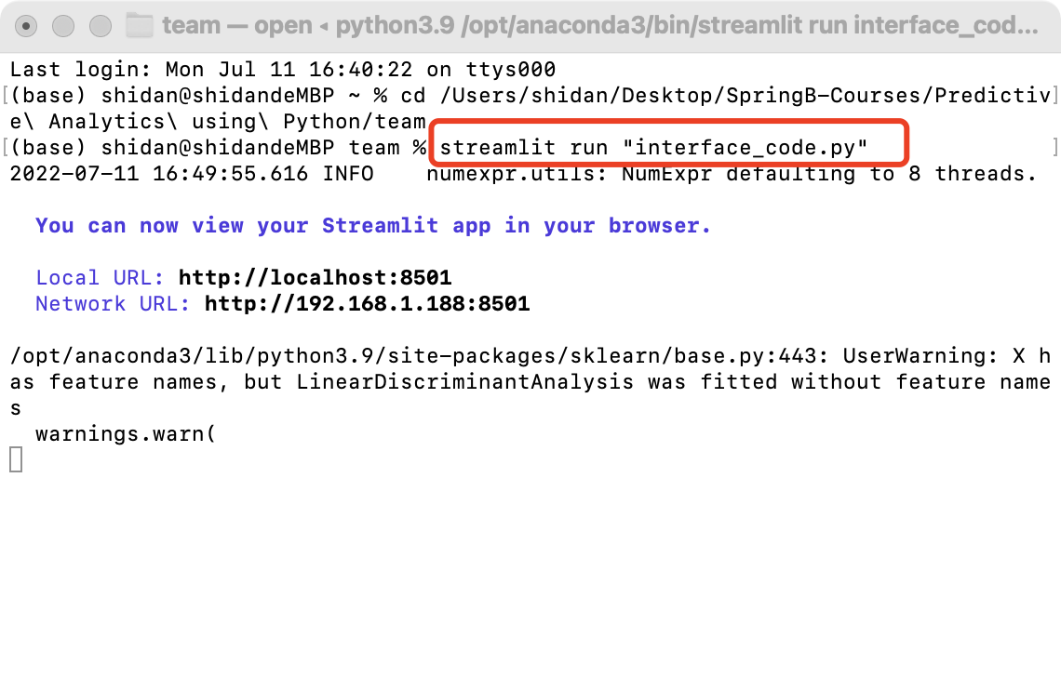

Part of the interface:

